Monday 18th March 2019
Today we have had a whole day on Hamlet. It started this morning with a drama performance with WEST END IN SCHOOLS. We acted out how different characters in Hamlet would have been and worked on a whole class performance of Hamlets famous speech ‘to be or not to be.’
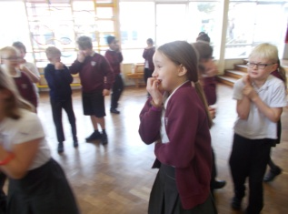
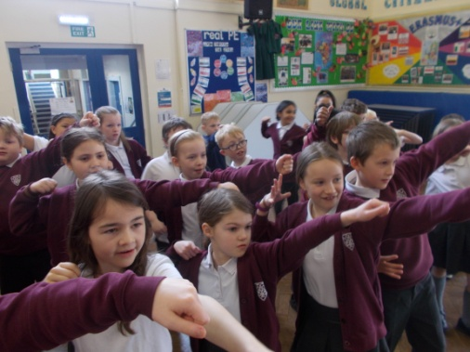
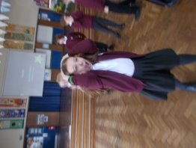
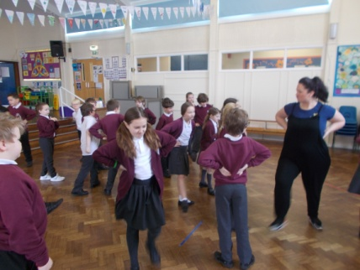
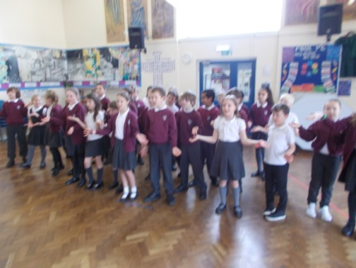

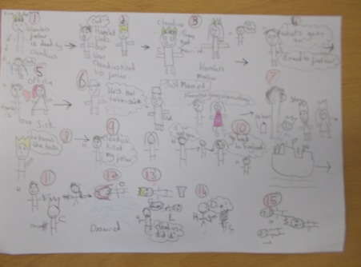
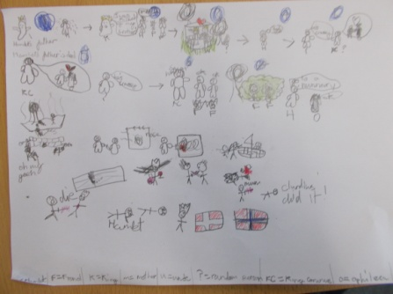
We then came back into the classroom and learnt more about the story. We looked at a PowerPoint and then produced our Stickman Shakespeare art work. We used stickman drawings to tell the story of Hamlet.

In the afternoon we watched the animated tales and discussed the story further looking at hamlets feelings and the reason why he acted in a certain way. We then worked in groups to create soundscapes of different emotions looking at facial expressions and changing our voices.
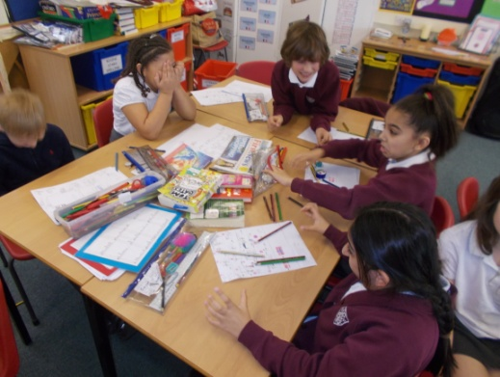
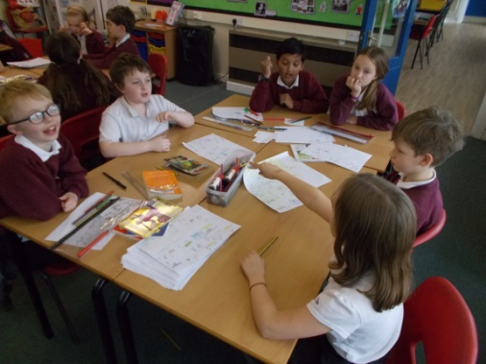

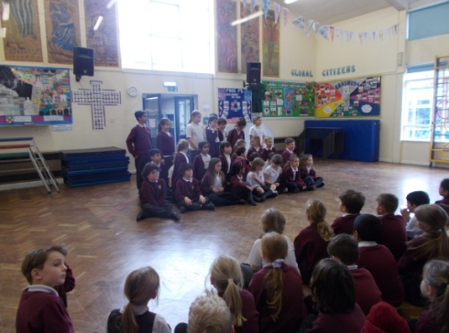
The day ended with a whole school performance of Hamlet.
