

**Watch this space for news of exciting Year 2 trips!**

**Other Subject Areas**

A lot of our curriculum is creative and we try to incorporate other subject areas such as music, art, geography and history into our topic work. In RE we will be encouraging pupils to learn about different religions, beliefs, values and traditions while exploring their own thoughts. This term, our focus festivals will Diwali (Hindu) and Christmas (Christian).

Circle time sessions will take place each week where the children will get chance to talk about their thoughts, feelings and emotions, including the Warwickshire ‘Taking Care’ PSHE programme.

**Science**

We are excited about our science learning this term which will link in to our main topic of Healthy Living. Starting with *‘Animals including Humans’*, we will learn about simple lifecycles, the basic needs for animals to survive, growth from baby to adulthood, eating the right foods and understand the need for basic hygiene. We will then continue to look at *‘Living Things and their Habitats’.*



**PE**

Games lessons are weather dependent and where possible will be outside. Please have a suitable winter kit including tracksuit bottoms, a jumper and suitable shoes.

Maple and Sycamore Class PE lessons are on a Tuesday with Mr Partridge for cricket and a Wednesday afternoon of outdoor games with Premier Active.

**Maths**

Our maths starts this year by securing knowledge gained in Reception and Year 1 and extending into Year 2 with an understanding of place value, addition, subtraction, estimating, measurement, money and shape.

It is really important that children understand numbers really well and can talk about how they are made up of 10s and 1s, 1 or 10 more, 1 or 10 less and pairs of numbers that are added together to make another number including number bonds to 10 and 20. We will also use our ‘sticks and dots’ method for addition and subtraction.

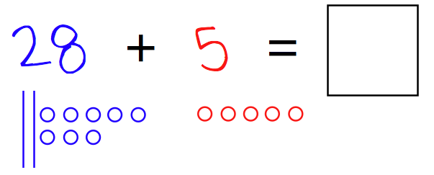

[](https://www.google.co.uk/url?sa=i&rct=j&q=&esrc=s&source=images&cd=&cad=rja&uact=8&ved=&url=http://www.energybc.ca/&psig=AFQjCNEGYPdJxYRAU4QttbxkjGU7yq61hA&ust=1452284882954672)

**Literacy and Topic**

Our literacy and topic learning this term will focus on Healthy Living –keeping active, eating a balanced diet and finding out where our food comes from. Our topic will start off with a mini festival of running to look at how exercise affects our body. To further consider healthy living we are creating our own Mr Men/Little Miss book called MR. HEALTHY. We will be designing our own characters and homes, then creating a scenario to help Mr. Lazy or Mr. Greedy to change their unhealthy ways.

As well as targeted phonics teaching we will have weekly SPaG lessons which focus on the spelling, punctuation and grammar used within the English language. Some of the children are learning joined handwriting, but correct letter and number formation is essential for this to be successful.

**Sycamore & Maple Class Newsletter – Autumn Term 2019**

Teachers: Miss Letchford & Mrs Smith (Maple); Mrs Stephenson & Mrs Vallins (Sycamore)

Teaching Assistants: Mrs Dawe (Maple); Mrs Hinks & Mrs Hutchins (Sycamore)

Welcome back to a new year at Emscote. We hope you had an enjoyable holiday. We have hit the ground running and thought you might appreciate an update of what this term holds in store. We look forward to meeting you properly at our parent/teacher meetings on 15th and 17th October.

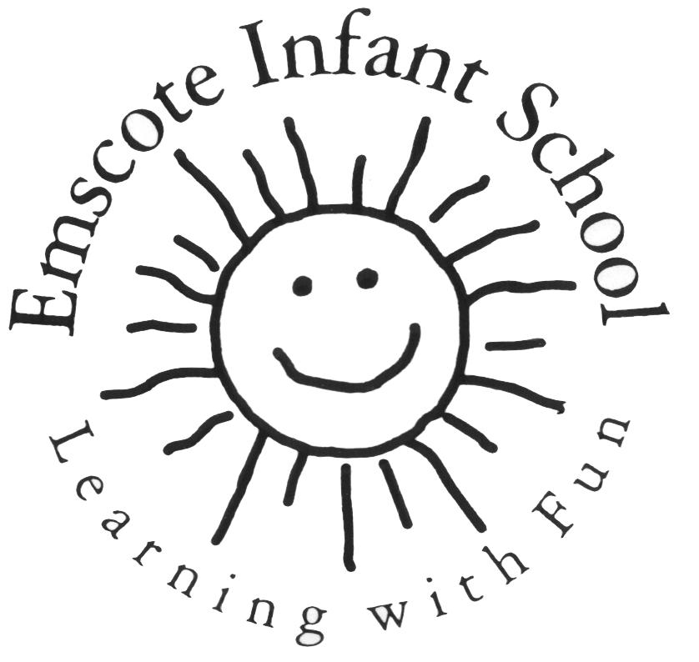

Please check book bags daily for letters!

**If you have any questions or concerns, please come in and see us. We have more time at the end of the day. Please let us know if anyone different is picking up your child so that we can write it on the board.**

**Mathletics**

Please support your child’s maths learning at home by using Mathletics. We will endeavour to set a task linked to our learning weekly. The log-ins are in the front of homework books.

[www.mathletics.co.uk](http://www.mathletics.co.uk)

**Our sharing assemblies are at 9:10am:**

Sycamore: Friday 11th October

Maple: Friday 29th November

Christmas Carol Service…dates to follow

**Homework and Spellings**

We endeavour to send homework out on a **Thursday**. It would be great to see 100% return of homework books by the following **Tuesday**. This allows us to mark and prepare them in time.

Phonics will continue in school. Children are often not in the same class for phonics as it is streamed on ability.

Spellings for the term are in homework books so please make a note of them each week. Please learn to read and write these words as it is an expectation for children at the end of Year 2.

**The children are tested on these every Friday.**

**Water Bottles**

Please remember that children need to bring in their own named water bottles as we no longer sell them at the office.

These will be sent home daily to be washed and filled.

**We now have a new water fountain in the playground!**

**Toast** – 20p per slice at morning break.

Children can bring in £1 to give to Mrs Robertson on a Monday for the whole week if that is easier.

**Reading**

Your child will have now received their new ‘Autumn Term Reading Diary’. We would like reading books and diaries to be in school daily. We aim to do Guided Reading once a week along with at least one individual read.

If reading books need changing, your child MUST put their reading packets in the changing box inside the classroom. Please encourage them to do this first thing in the morning. It gives us the opportunity to change the book and update their reading record - thank you.

We would also encourage parents to read the notes in the front and back of the reading diary to give some guidance when listening to your child to read.

**Please remember that our expectation is that you will read 4 times a week at home please!**

**Clothing for Colder and Wetter Weather**

Please ensure your child comes in with a named, warm, waterproof coat every day. They are also welcome to bring in a pair of named wellies as we do encourage the grassy area to be used throughout the year – and they can visit our resident chickens!

[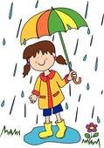](https://www.google.co.uk/url?sa=i&rct=j&q=&esrc=s&source=images&cd=&cad=rja&uact=8&ved=0ahUKEwils9_hwJjKAhVBchQKHdnpCSIQjRwIBw&url=http://www.fotosearch.com/photos-images/rain-coat.html&psig=AFQjCNFmbm61zhMnkk71pVlHISP88tNA3w&ust=1452283632674805)