Monday 18th March 2019
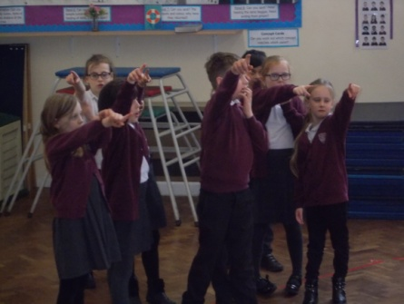
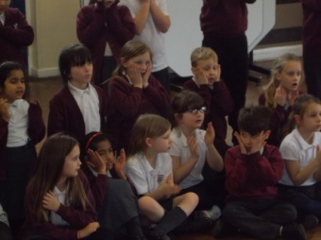
Today we have had a whole day on Hamlet. We have taken part in a drama performance with WEST END IN SCHOOLS. We acted out how different characters in Hamlet would have been and worked as a whole class.
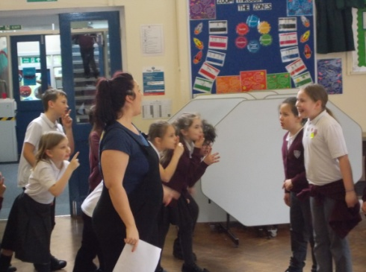
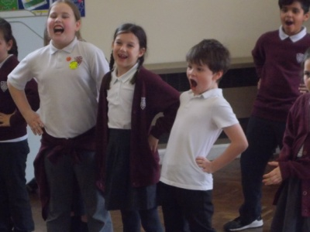
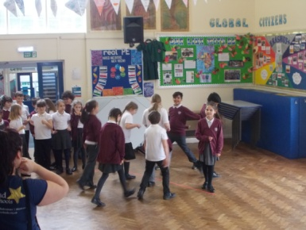
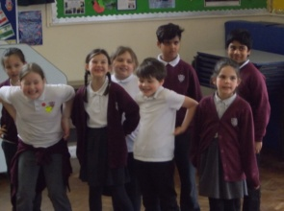

We watched the animated tales and discussed the story further looking at hamlets feelings and the reason why he acted in a certain way. We then worked in groups to create soundscapes of different emotions looking at facial expressions and changing our voices.

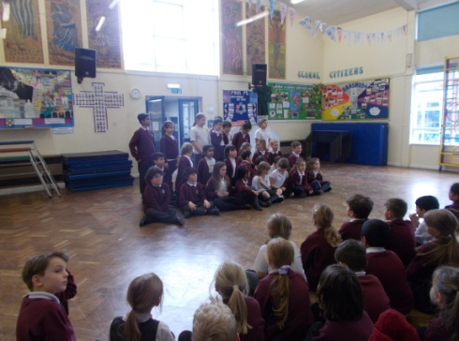
The day ended with a whole school performance of Hamlet.
