Home Learning Year 5 (16th November 2020)
Hello Year 5, we hope you’re all keeping well. Please find below the home learning for this week.

English:
Below is a link to the National Academy – this should be familiar to you as it is the website we used during lockdown. We are asking the children to complete lessons on persuasive writing. This is an area of work we have recently covered so this will be a good opportunity for the children to consolidate their skills.

Please follow the lessons daily so that by the end of the week your children have completed the first 5 lessons in the sequence. Lessons 1-5.

https://classroom.thenational.academy/units/school-uniform-persuasive-writing-4ef1

Topic:
Continuing our learning about the Anglo Saxons, this week we will be looking at how Anglo-Saxons lived.
Using the links below and the information on the next page, gather information about :
- How are AS houses made?
- What were there houses like?
- What were the villages like?

https://www.bbc.co.uk/bitesize/clips/znjqxnb
http://www.primaryhomeworkhelp.co.uk/saxons/houses.htm
https://www.bbc.co.uk/bitesize/topics/zxsbcdm/articles/zq2m6sg

You then need to create their own Anglo-Saxon Village.
This should be a drawing that is labelled.
On a separate sheet please answer the following questions:
- How are AS houses made?
- What were there houses like?
- What were the villages like?

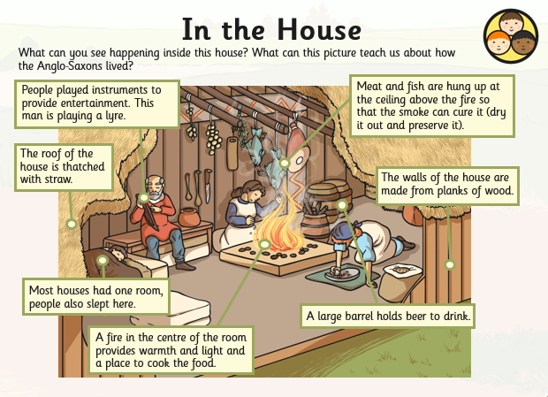
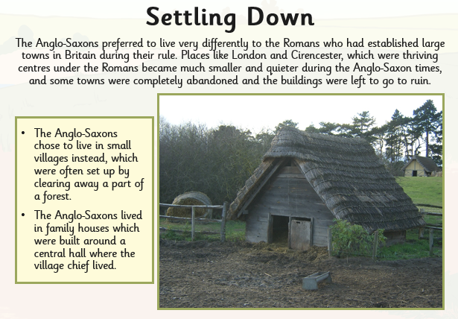
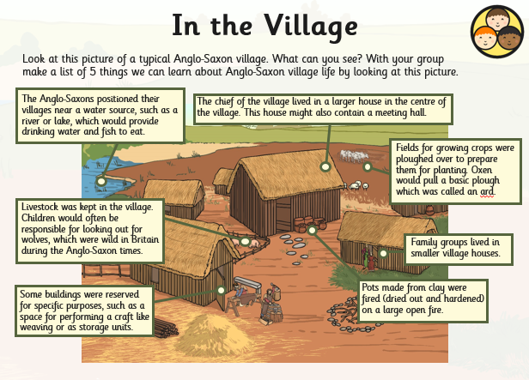
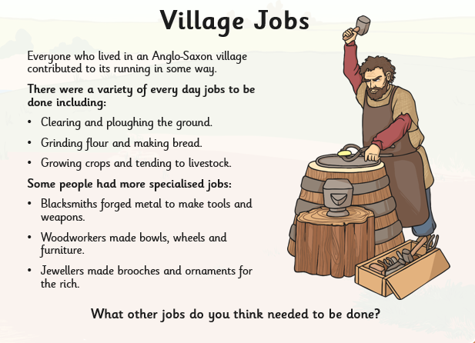

Science:
This week we were going to set up the experiment about decay of food and packaging that we planned last week. This was going to be a pile of food and a pile of food packaging placed on soil to observe the differences in their decay. Remember to place a covering over the piles so the packaging is not a danger to any wildlife in your garden.
If you are not able to do this please do not worry. You can just do the next activity instead.
Using the table, below we’d like you to take a note of everything that is left over from your lunch every day this week and tick whether it can be reused, recycled, composted or if it would need to go to landfill.
For example, if you had a sandwich, a packet of crisps and a banana then the plate that you ate from could be reused, the left over crusts composted, the banana peel composted and the crisp packet would go to landfill.
If you’d have been at school your sandwich may have been wrapped in cling film, so you would need to think of an alternative such as a reusable container.
At the end of the week you can then write down what you have noticed about how environmentally friendly your lunches are and what changes you could make to improve them.
Environmental lunch log worksheet
Item | Reuse | Recycle | Compost | Landfill | Could be replaced with?
Crusts |  |  | √
Banana Peel |  |  | √
Crisp Packet |  |  |  | √
Cling film |  |  |  | √ | Reusable container

Maths:
This week please have a look at statistics.
Lesson 1: https://vimeo.com/462717846
Lesson 2: https://vimeo.com/462718768
Lesson 3: https://vimeo.com/464199475
Lesson 4: https://vimeo.com/464199475
Lesson 5: https://vimeo.com/464197707

It is also really important for lots of areas of maths that children know their times tables for instant recall. Once they know this then they can use the facts in larger calculations and manipulate them. If possible use ‘Hit the Button’ for learning the tables, it is a free online game that they can play.

https://www.topmarks.co.uk/maths-games/hit-the-button

If you cannot do this then making a matching game with pieces of paper where they have to match the calculation to the answer is just as effective.

