If you like you can use this prayer:
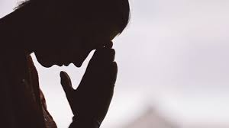

Dear God,
It is sad to think that people today live in a world where there is persecution and extreme suffering.
We pray for anyone who is facing the prospect of being uprooted to find safety in a new place.
We pray for protection and safety for people who are forced to leave home to seek safety elsewhere.
We pray for strength and wisdom for those people who support refugees
And for charity workers and agencies here in the UK who help refugees.
We pray that refugees who need safety might find welcome in a new place, so that they can feel secure and thrive in their new environment.
We thank you for the many ways in which the UK has benefited from the creativity and resilience shown by many refugees in the past.
Amen

