All Saints’ CE Junior School - Year 4 wc: 22.6.2020
Hello Year 4 – We hope you are still enjoying our Rainforest topic and are liking the changes we have made to literacy work. We were sad to hear the government’s news that no other year groups will be back at school this year. However, it is for the best and we are planning a virtual surprise to celebrate the end of year 4! Please keep in touch but note that Mr. Jacobs is teaching all week, and Mrs. Ross is on Mondays. We should be able to get back to you during the school day Tuesday-Friday, but you might have to wait until afterschool to hear back from one of us on Mondays. We would just like to re-iterate that there is no expectation about the amount of work you complete from this sheet.
From Mrs Ross, Mrs Garrett, Mr Jacobs and Mrs Matthews.
Homework | What to do… |  | What to write down… |  |  | Extra information…
Daily reading | Read by yourself, to a parent or a brother or sister for at least 30 minutes every day.  Other resources include:  1.Serial Mash-Online library of fiction books  There are stories about almost everything. Each book has quizzes and activities to explore. Start your first chapter now and begin an adventure.  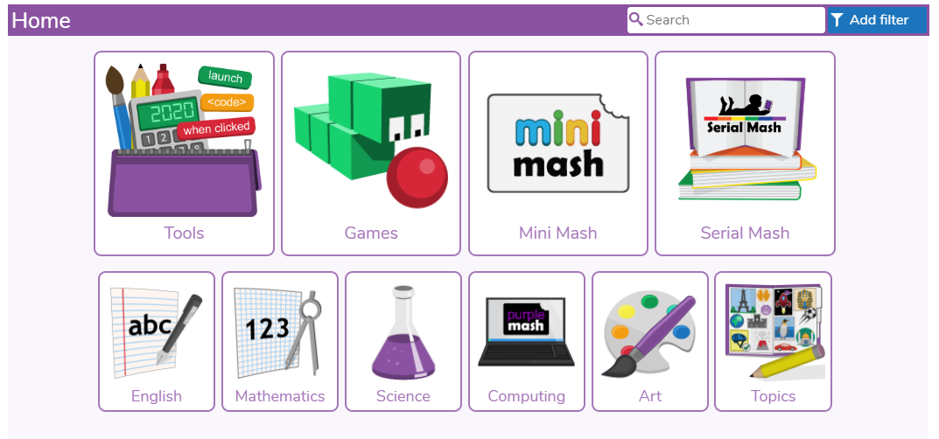  Books that you read at home you can now complete quizzes for using Accelerated Reader. You can click on the link below and type in your normal log in details.  https://Ukhosted82.renlearn.co.uk/1895399  (there has also been a letter sent home about this)  The following website has over 7000 online books/texts (95% of these can also be accessed as audio books as well). Also, the majority of books are linked to AR and have quizzes that you can complete when you’ve finished reading: https://readon.myon.co.uk  David Walliams is also reading a chapter from one of his books at 11am every weekday. You can also listen to the previous week’s chapters here: https://www.worldofdavidwalliams.com/elevenses-catch-up/  BBC Bitesize has reading lessons: https://www.bbc.co.uk/bitesize/articles/zknnf4j  Here you can listen to actress Joana Lumley read a book called You're a Bad Man, Mr Gum there are 3 activities where you will learn about how an author creates humour, and how to write dialogue in the style of the author. |  | Record who you read to and what you read in your reading diary.  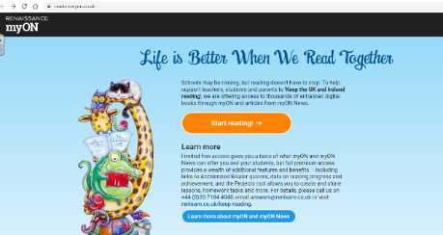  Click the orange button. |  |  | Try and use the time to really enjoy reading books and try new books if you can. If you do not enjoy the books you bring home from school, feel free to choose one from home.  If you are still struggling to find books to read then you can try the website below – you can choose books for your age/reading ability and read them online for free.  Go to www.oxfordowl.co.uk click my class login button.  4RG: Username: allsaintsyear4RG  Password: abc1  4MJ: Username: allsaintsyear4MJ  Password: abc1  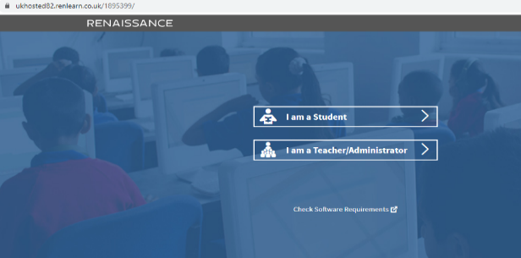  1. Click on ‘Start Reading!’ You’ll find a huge range of books, if you use the ‘Search’ button you can find books suitable to your reading level.  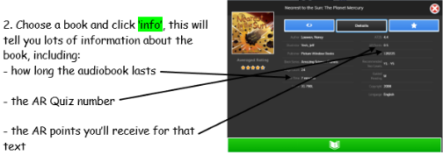
Daily spellings | Each week you will be set a list of words to practise. Different children will have a different set of words aimed at bringing on their own individual spelling skills.  Monday – Read your spelling words and write them out to practise your handwriting.  Tuesday - Look, Cover, Write, Check with the words three times.  Wednesday – Are there any tricky parts of the word? How can you remember them?  Thursday - write each word in a sentence.  Friday – Create your own poster with the words/or a spelling quiz |  |  | You don’t need to write anything down – we will be able to see your activity and progress online.  supermarket superman  superstar superhuman  antiseptic anticlockwise  antisocial autobiography  autograph automatic |  |  |  | Once you have completed the homework assignment then you can choose Stage 3 and 4 words that you can play games with. If you find these too difficult try Stage 1 and 2 words.  For something different why not try making a word search using this week’s spelling words?
Daily writing | This week we are going to learn about palm oil and how it’s leading to deforestation around the world. You will find the powerpoints and reading comprehension attached to an email from the office. I have labelled each resource with the day to complete it on to avoid confusion. You are going to be writing a persuasive letter to convince companies to stop using unsustainable palm oil. This week your writing will help change the world and save endangered orangutans! If you have any questions feel free to email us but bear in mind that we are unable to respond during the school day on Mondays.  Some parents have said that they prefer the BBC Bitesize, Pobble or National Academy. It is fine to swap to something different.  Monday: Read and Learn about Palm Oil you should find a PDF file titled Monday – Palm Oil Reading Comprehension there are three levels (one star, two stars, and three stars). Pick one star if you find reading and answering questions a bit tricky, two star if you don’t find it too tricky, and three star if you want a challenge. After reading answer the questions that match your level and you can check your answers by scrolling to the bottom. Afterwards, divide a piece of paper in two and write for on one half and against on the other half. Try to find as many reasons as you can for palm oil and against palm oil. You may want to do more research. This BBC newsround story is a great place to find reasons for and against palm oil: https://www.bbc.co.uk/newsround/39492207  Tuesday: Researching Orangutans one animal that has been affected the most by palm oil deforestation is the orangutan. They are an endangered species and they are losing more and more of their habitat to palm oil farming. We are going to do some research about these fascinating creatures to learn more about why we should protect them.  Shorter video made for children to understand: https://www.youtube.com/watch?v=MRjNq0hoUrU  Longer, more detailed/challenging video about orangutans: https://www.youtube.com/watch?v=0fts6x_EE_E  Afterwards, go to the bottom of this document and find Tuesday’s sheets. There should be a fact sheet about orang-utans and a blank one for you to fill out. If you want to learn more about these fascinating creatures look at: https://kids.nationalgeographic.com/animals/mammals/orangutan/ and https://kids.sandiegozoo.org/animals/orangutan if you click the live cam button that looks like this you’ll get to see what the orangutans at San Diego zoo are up to!  Wednesday: Looking at Iceland Palm Oil Advert watch the banned Iceland Christmas advert from 2018 here: https://www.youtube.com/watch?v=TQQXstNh45g . The ad was made by Green Peace an environmental charity/organisation. Have a look at a powerpoint titled Wednesday – Banned Iceland Ad. This powerpoint will explain more why the ad was banned from airing on television and recap information about palm oil. Do you think this ad is too political? Was it the right decision to ban it from T.V? Why do you think some people wanted it banned from T.V.? Then watch this video which showcases https://www.youtube.com/watch?v=IFACrIx5SZ0 just how smart these creatures are! Create a venn diagram to compare and contrast humans and orangutans (there is a sheet at the bottom of this document to help you). Write down your three favourite facts about orangutans to use in your persuasive letter.  Thursday: Planning Letter Go through the powerpoint titled Thursday – Persuasive Letter Features and Examples you will learn about what you need to include to make a letter persuasive and get to see two examples. Pick a company that you want to write a letter too. You are going to try and persuade them to stop using unsustainable palm oil in there products. You can look in your cupboards for products that contain palm oil that isn’t certified. If you need ideas some companies that still use rainforest-destroying palm oil are: Oreo, Cadbury, Greggs, Warburtons, Kellogg’s, Dove, and Nestle. To help you write you letter and make sure you are including facts and arguments use the word mat to help you write out your letter (at the bottom of this document). You may need a parent to help you find the address you should send your letter too.  Friday: Editing and Publishing. Go over your plan from yesterday and check for spelling and punctuation errors. Make sure you’ve included all the features from the powerpoint. You may want to get someone else to read it to give you feedback. After you’ve made all your corrections, copy it up on a nice piece of paper using your best handwriting and mail it! If you are unable to mail it you can type it up and send it to the year 4 email address. Mrs. Ross will print the letters out and mail them to the companies you’ve chosen. It is important that your hard work is seen, the more letters companies get the more likely they are to change!
Daily Maths | - Look at this website: https://whiterosemaths.com/homelearning/year-4/  We are going to focus on Summer term Week 7 (week commencing 8th June)  There is a video on the website and the activity sheets are attached to this email. The answers are on the year 4 home learning page on the school website.  If you find this a little tricky or too easy you can always try Summer Term- Week 7 of Year 3 or Year 5 (you can find these on the right-hand-side of the screen). The activity sheets have been emailed in a separate document.  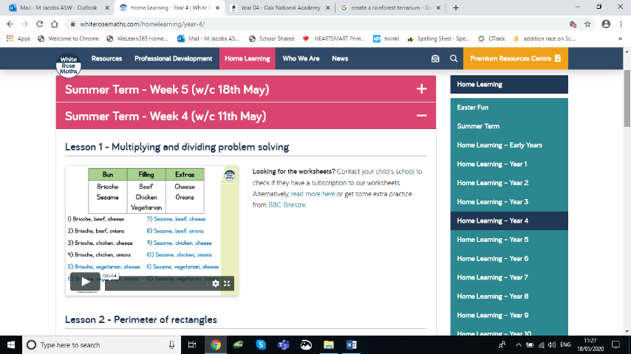  2.Use hit the button to learn your tables  https://www.topmarks.co.uk/maths-games/hit-the-button  Focus on whichever table you feel you need to practice this week. Remember you should KNOW the answers, not have to work them out (by counting up) – Those are the tables you should focus on. For example, most of you know the 10x table really well and can get a high score in that one. You should be able to do the SAME in all of your tables.  Don’t just play games on the tables you know well.  If you are getting bored of Hit the Button then Move on to J2E blast on we learn. You can practice your tables knowledge and mental calculation skills against other people!  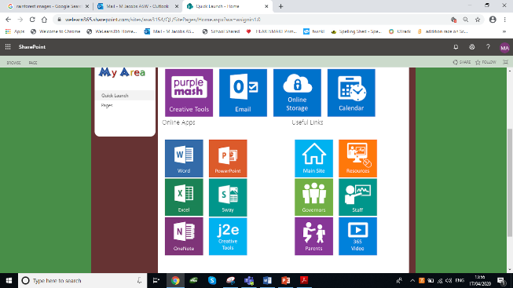 | If you have access to a printer you can print out the worksheet. If not get a piece of paper and write your answers down on that instead.  Some parents have said that they prefer the BBC maths or the Maths lessons on the National Academy instead of the White Rose lessons. It is fine to swap to something different if it isn’t working for your child. Please feel free to do this.  You can record your scores and keep a record of the table you are on and the score you have got |  |  |  |  | There is a lesson to follow for each day of the week. You can find the answers on the year 4 home learning page on the school website.  Remember you also have your Prodigy logins that you can use – there will be an assignment on adding and subtracting fractions– don’t worry if it is tricky to begin with the game will adjust to your maths level as you play.  If you are really confident try hit the question or even go onto the division section. These will really test your knowledge of your tables!  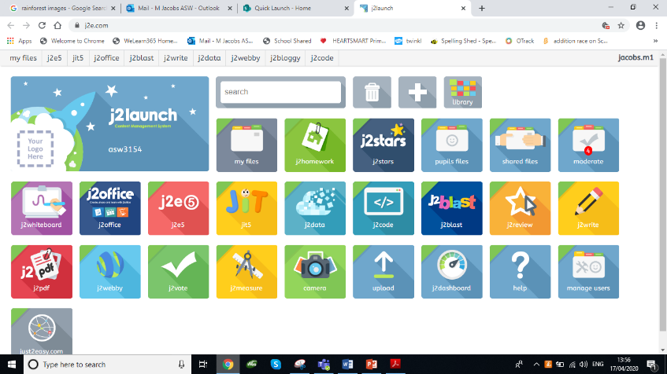  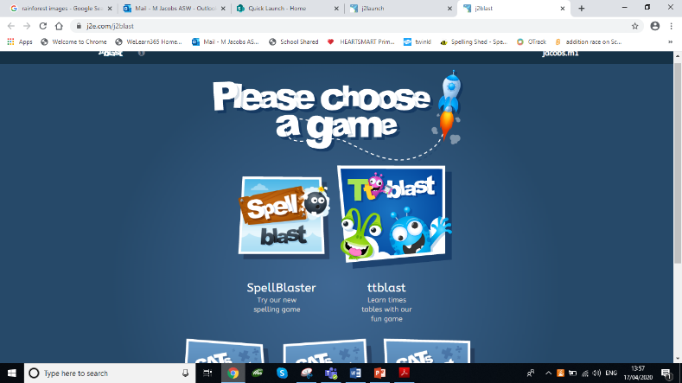
Weekly  Topic work | Open South America Climate Zones Slides which is attached to the home learning email. Go through the slides to recap what you learned last week and learn about the different climate zones found in the world, focusing on South America. How is the climate in the rainforest different to the climate in the U.K? What different climate zones can you find in South America?  Look at an attachment labelled South America Climate Zones Worksheets. There you will pick one of the three following worksheets and if you want you can do the other sheets as well.  Simple: Try worksheet 2A you need to look at climate zone map of South America (page 4) to answer True or False questions.  Medium: Worksheet 2B look at climate zone map of South America (page 4) to answer questions.  Challenge: Worksheet 2C you will need to describe what type of climate you would find in different climate zones around the world.
Extra  P.E | There are a variety of extra fitness challenges you can try here:  http://www.thinkactive.org/wethinkactive/kids-active-learning/a-z-challenge/  The challenge is to complete all 26 challenges, so that you’ve completed a fitness challenge for each letter of the alphabet. This is something you can try and complete over the next few weeks, so no rush!
Weekly  Science work | We are going to continue using Seneca this week. Let us know what you think and if it is too tricky I have linked a video you can watch instead (on the bottom). I can see that some of you have been using the site already! Try this video and quiz if Seneca doesn’t work: https://www.bbc.co.uk/bitesize/topics/zn22pv4/articles/z8mbqhv  - Click this link https://app.senecalearning.com/dashboard/join-class/00ss3h12ea  - Enter in the email and password you want to use to access this site. You should automatically join class 4RG (even if you’re in 4MJ)  - 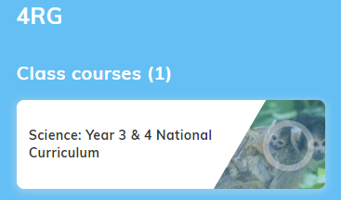 you should see this on your screen click the science year 3 and 4 national curriculum.  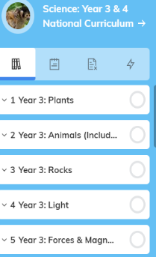  - It should take you to a page with this sidebar on the left. Scroll down using the grey line on the side and select the unit called 6 year 4: Living Things and Their Habitats.  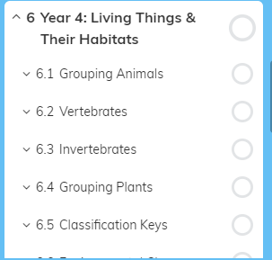  - When you click on that unit it should expand to look like this. Click on 6.3 Invertebrates. You should see all the subections (6.3.1 to 6.3.5). Click on 6.3.1 and a blue button that says start learning should appear on the main screen, click it. |  |  |  | If you’re using Seneca you will learn and it will quiz you as a go along. This is to help you retain the information. Don’t worry if you can’t do all 5 subsections at once, you can take your time and do them over a few days.  Once you’ve finished learning about the different types of invertebrates you are going to go on a minibeast hunt! You can use your back garden or a local park/wooded area to do this.  Take notes of what you find and whether is a slug, snail, worm, insect or spiderIf you come across minibeasts you are unfamiliar with, look up invertebrates classification key to help.  If you’re really keen you can create a mini fact-file on your favourite mini beast and label it. Be sure to include a lovely illustration!

Enrichment Ideas | Please see the ideas below. Complete these tasks if you have time and you would like to.
Board Games  Play some board games with members of your family and have some fun. If you can’t find one you all like then why not try making one you can all agree on! |  | Become A Chef !  Why not try making a meal for your family?  You could go simple like lunchtime sandwiches or you could choose to make an evening meal. We leave it up to you (and your parents!) to decide. |  | Sports Highlights  You could write a number of different past years at random on pieces of paper, or for example, write all years from 1990- 2005.  Pick one out of a pot each day and search up all the sporting highlights of this particular year.  Enjoy watching them on You-tube with your family - everything from FA cup finals to world indoor athletics.
Make your own Terrarium!  This is a great way to observe the water cycle for yourselves, in your very own mini tropical rainforest.  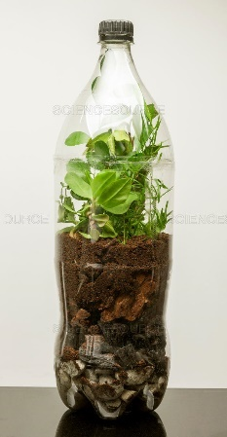  You could use a 2 litre plastic bottle cut in half, just remember to seal it up with tape when you put the top half back on (to keep the water inside).  Watch this video for instructions:  Watch this video: Sci show kids video  https://www.youtube.com/watch?v=0vu4wdHNo4Q |  | Physical Challenge  How long can you jog for / cycle for each day?  When you go out with your parents try to increase the amount of activity you do each time.  Even if it is only by a few minutes. | Make your own pavement paint!  https://www.argofoodservice.com/recipe/DIY-Homemade-Sidewalk-Chalk-Paint  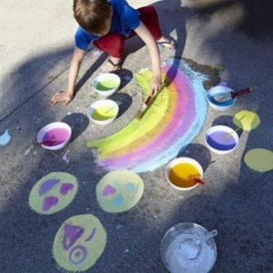 |  | Grow your Own Crystals and Eat them Too!  If you have string, a lolly stick or pencil, sugar, a paper clip and a glass jar you can make crystals at home!  Follow the instructions here  Get an adult’s help as you will need hot water.  http://www.sciencefun.org/kidszone/experiments/crystal-candy/

Topic Homework Grid:  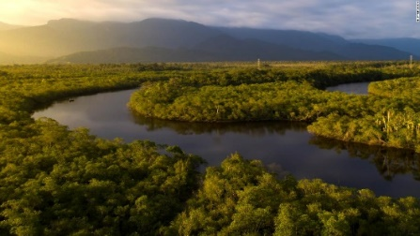  Year 4 Topic – ‘Rainforests’ |  | 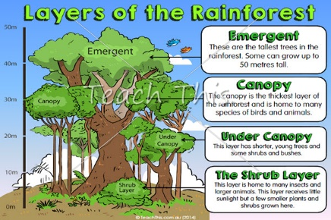  ‘Rainforests’  Over the Summer term you will need to complete at least three of these ideas, feel free to do more if you like, or create your own ideas!  Keep your models/art work etc at home (you could take photographs of these if you prefer). PowerPoint presentations and photos can be emailed to year4ASW@welearn365.com or saved on a named memory stick.
Become an expert artist  Can you be a botanical artist?  Find out what a botanical artist is and try to draw a picture in the same style. | Create a PowerPoint presentation about Rainforests.  Include: locations around the world, layers of vegetation within the forest, animals found in these and the impact of human activity on rainforests. |  |  | 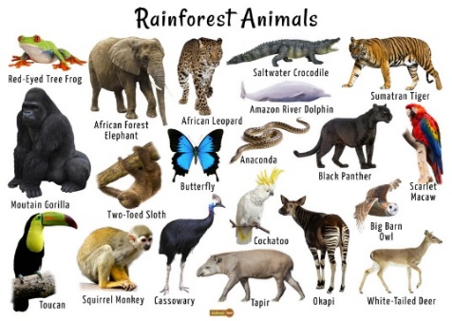  Create a habitat for an animal that lives in the rainforest using a box and materials you have at home. Think back to when we created habitats in a box for science back in Autumn. Try to include things your chosen animal would eat in its habitat. |  | Find out about products which come from the Rainforest.  - Identify what they are used for and who uses them. - Search your house for products that come from the rainforest, you’ll probably find a few? - Research how far have these products had to travel for you to use them.
Make your own rain stick!  Using materials around your house and a bit of dry rice you can make your own rain stick. See instructions here https://theimaginationtree.com/diy-rain-stick/ and here https://www.bakerross.co.uk/craft-ideas/kids/aboriginal-rain-stick/  Have fun with your new instrument and you can even create your own rain dance. Make sure you conduct some research to find out who used them and how they are traditionally made. |  |  | Have a go at growing some of your own plants. Take pictures to keep track of your plant’s growth. If you don’t have seeds there are plenty of things you can grow from food scraps on your windowsill such as lettuce and green onions. You can find more ideas here  https://www.diyncrafts.com/4732/repurpose/25-foods-can-re-grow-kitchen-scraps |  | Make yourself a Minecraft model of a rainforest animal.  Minecraft cubes are big so, to get in lots of details, you will have to make that the statue is big!  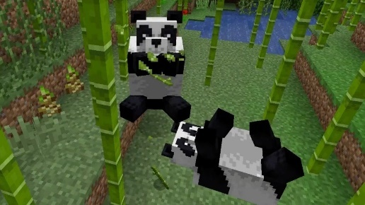 |  | Can you complete the alphabet game?  Can you think of the name of a rainforest creature for every letter of the alphabet?  Perhaps you could make it into a poster with illustrations.
Tuesday 23.6.20
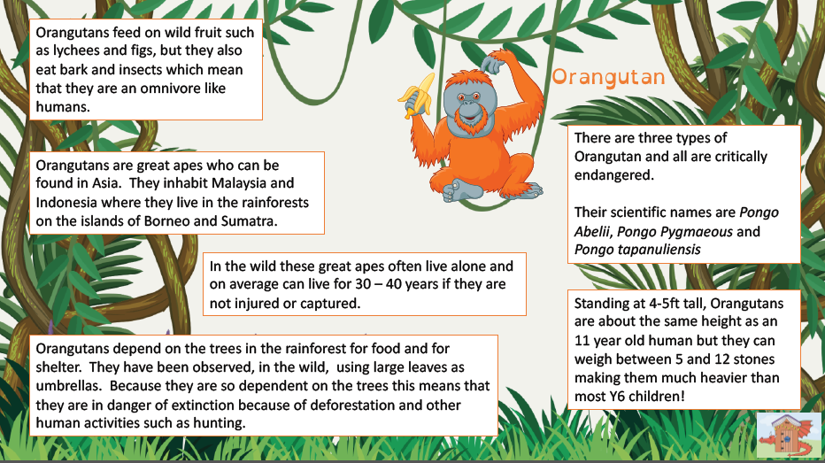
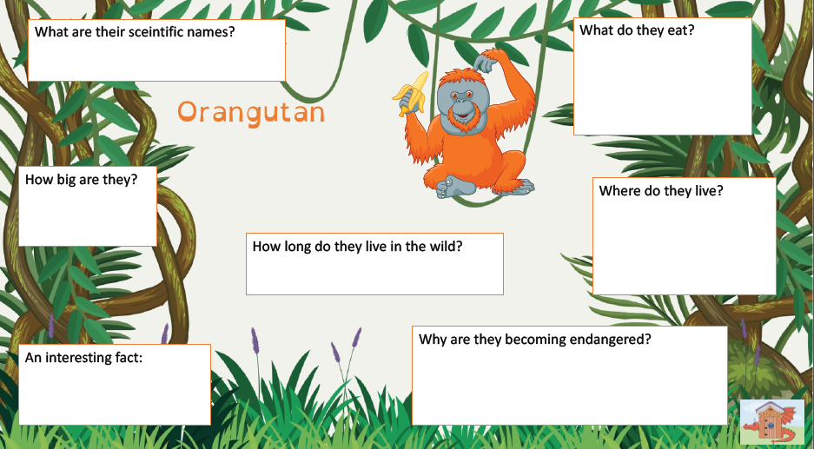
Tuesday 23.6.20
Wednesday 24.6.20

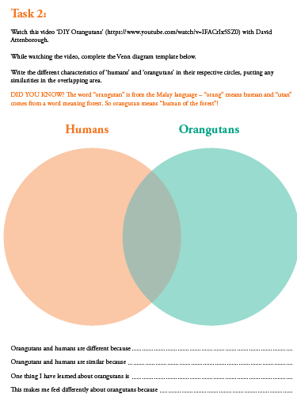
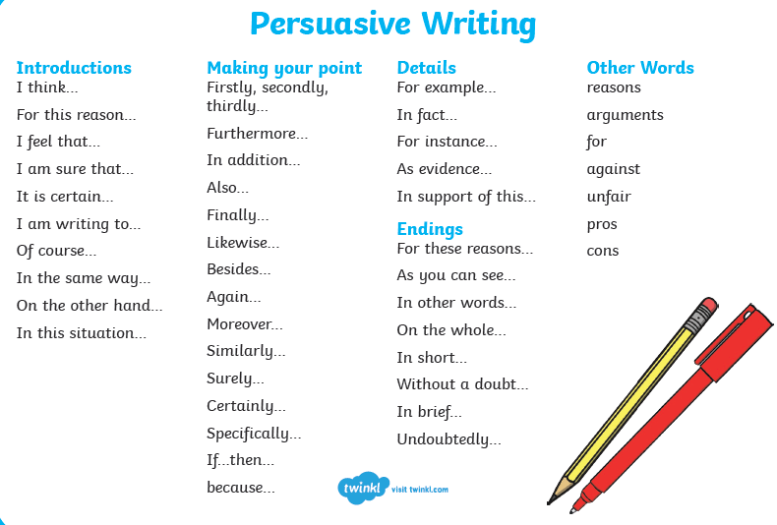
Thursday 25.6.20

