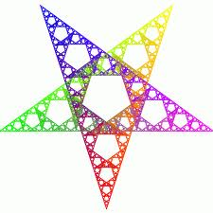
Happy New Year!
Here is a brief summary of what year 4 will be studying in each subject this term. As always, if you have any concerns or questions throughout the year, please do come and speak to any of the year 4 team.

We are continuing to use Accelerated Reader and your children will be completing a quiz on the computer each time they finish a book so please keep encouraging your child to read.

We are looking forward to having many new adventures with you this term.
Miss Snow and Mrs King
English  SPEAKING and LISTENING  Through discussion in large and small groups, as well as drama activities, the children will develop the confidence to contribute in class. They will also be encouraged to listen and respond sensitively to the opinions of others.  READING  Skills of decoding text and comprehension will be developed through shared, guided and class reading.  WRITING  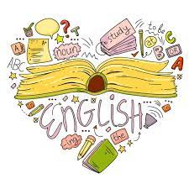  The children will continue to learn about different text types. This term, we will be looking at: traditional tales, recounts, explanation texts, poetry and narrative fantasy stories. We will use different books/media alongside to teach these text types. | Maths  The curriculum will be used to extend children’s knowledge, understanding and application in these areas:  -Multiplication and Division  -Addition and Subtraction  -Fractions  -Decimals  -Shape  Through mental starters, we will be recapping all areas of maths and knowledge they have learnt last term or in previous years.
 | In both Maths and English, children will meet these areas of learning at their own level and pace.
Science  This term, our Science unit is electricity.  Children will learn:  - That some materials allow electricity to flow through them and others do not.  - To construct a simple series electrical circuit and, that the different components of a circuit have different and specific functions.  - To recognise some common conductors and insulators, and associate metals with being good conductors  We will also be studying states of matter.  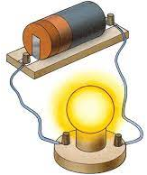  The children will learn to:  - Compare and group materials together, according to whether they are solids, liquids or gases  - Observe that some materials change state when they are heated or cooled.  - Identify the part played by evaporation and condensation in the water cycle and associate the rate of evaporation with temperature. | Computing    We will be learning the basics of the Microsoft Office software and practising creating word documents/ power points and databases. We hope to develop our skills to help us use ICT across the curriculum.
Physical Education
This term, the children will be looking at these areas in particular: invasion games, circuit training/multi-skills, yoga, gymnastics and basketball/netball.

The children will have Outdoor PE every Friday and Indoor PE every Wednesday.

Please ensure that your child comes to school in appropriate PE clothing, with school uniform jumper/cardigan.
Religious Education - In RE we encourage everyone to think, reflect and ask questions.


Sikhi worldviews: This unit explores what it means to be a Sikh and what is important for some/most Sikhs, around the world. We will also explore Sikh practices and their place of worship, the Gurdwara.

What or who is ‘God’ and how is the divine understood in theistic worldviews?: This unit will explore some ‘big ideas’ in RE, giving children a chance to think and reflect on key questions.
Geography & History:
Romans: We will learn about the Romans and the impact on British history. For example, Hadrian’s Wall, money and the expanding empire.
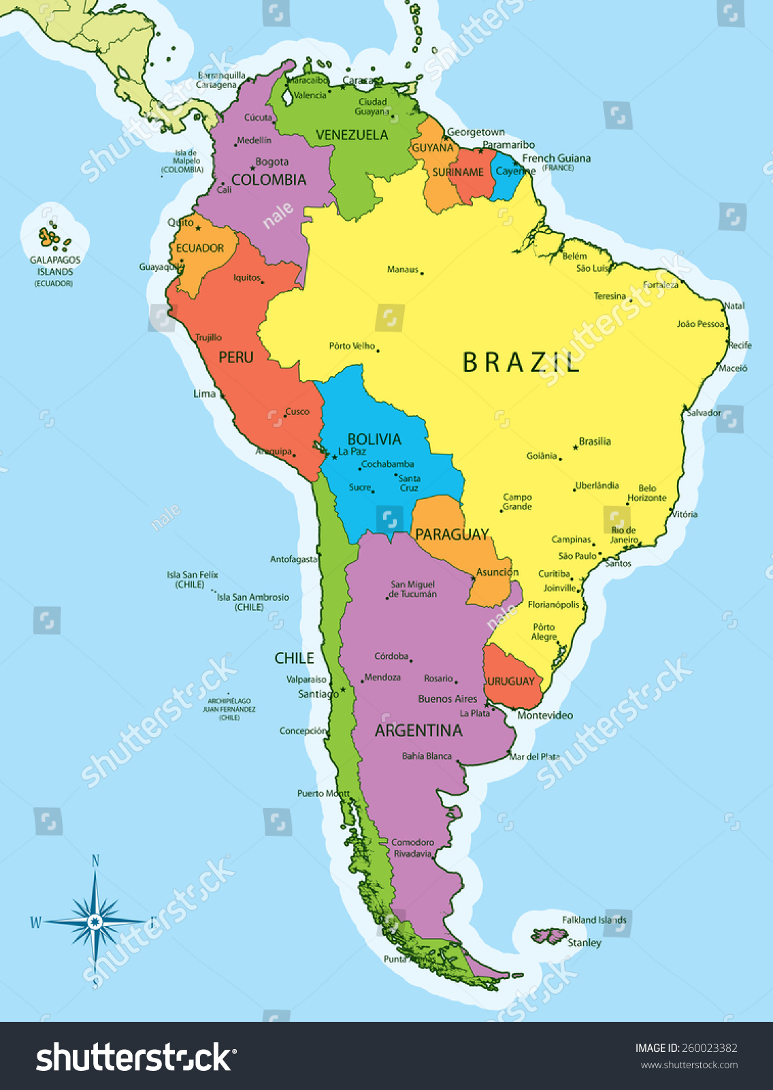
South America: We will learn all about the physical and human features of South America, including population, capital cities, the Andes and the climate.
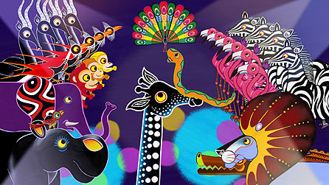  Art and Design Technology  Art of Africa – We will be looking at natural patterns in Africa, incorporating artwork in the style of ‘Tingatinga’ artwork.  Seasonal foods – looking at seasonal food available for the UK, investigating food miles, experimenting with cooking techniques and encouraging healthy eating. | Music    Children will experiment with a variety of instruments and the initial focus will be on rhythm and pulse. The children will learn to read rhythm symbols and keep a regular beat. They will use their body as a musical instrument.
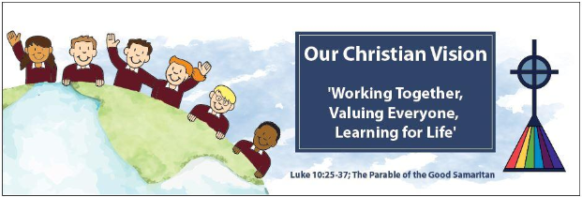 | PSHE Education  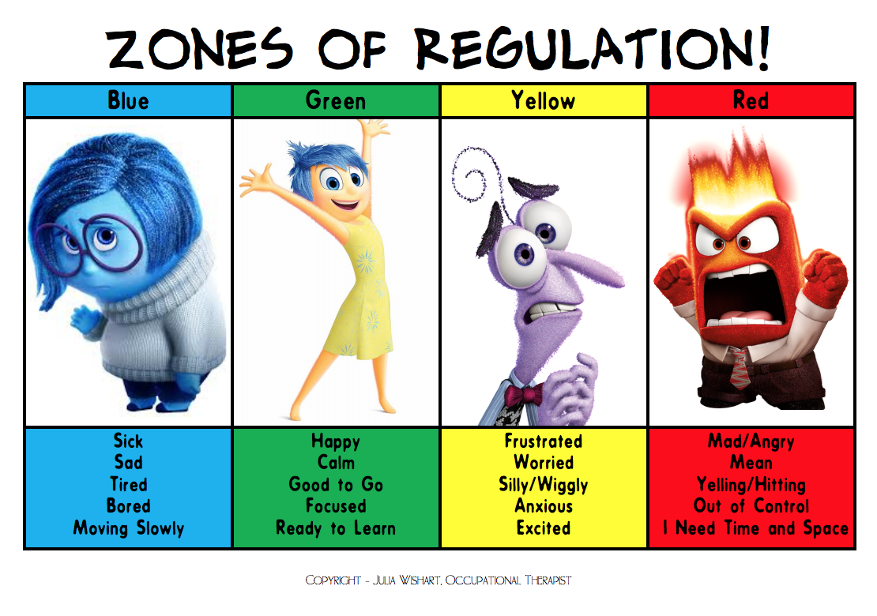  This term, we will continue to intertwine the Zones of Regulation. We will learn about online bullying and online reputation. We will also consider self-image and identity,

