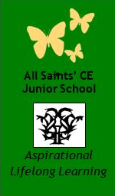

Dear parents and carers,

Grandparents’ Afternoon Tea at All Saints’ CE Junior School

Children can invite their grandparents to join them for afternoon tea on Friday 10th November at 2.15pm. The cost is £5.00 per adult and £5.00 per child.

Menu
Assorted Sandwiches
Mini cakes
Scones with jam and cream
Tea or coffee/fruit squash

If you have any dietary requirements please contact the school office: admin3154@welearn365.com

This is a limited ticket event so if your child would like to take part with their grandparent/s then please log on to www.eduspot.co.uk to book your tickets. Please follow the link for the SHOP tab and pay for places required. Please note that places are limited and allocated on a first come, first served basis. Payment must be made at time of booking to secure your places. No physical ticket will be issued.

If you have children at Emscote and you wish them to join you here please book places for them at All Saints’.

Kind regards,

Sandra Sutherland
Headteacher

