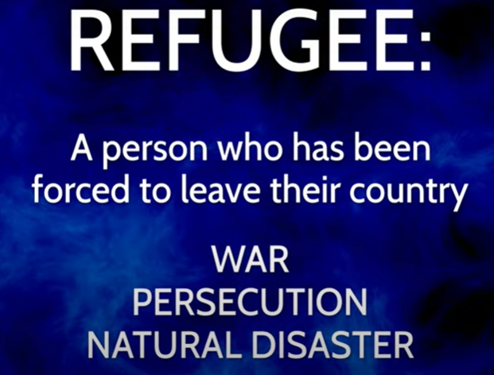

Lots of people all round the world have had to leave their homes – not by choice.

Imagine living in a tent…for months…for years…

It’s good to think about or pray for people who have become refugees.

Take a dot to place somewhere on the globe:

* You could pray for a country which is receiving and welcoming refugees.
* You could pray for a country from which people have had to flee because of

war, persecution or natural disaster.